IDBI Bank Limited

API Design - Perform Account Inquiry - Draft Report

|  |
| --- |
|  |
| *23 November 2021* |
| *DRAFT* |
| *Strictly Private and Confidential* |

# This page is intentionally left blank

Change history

|  |  |
| --- | --- |
| Document Information | |
| Document Title | IDBI API Design - Draft Report |
| Document Purpose | The purpose of this document is to design the process of the digital servicing of its savings account’s customers for greater reach of its savings account product, thereby increasing cross sell opportunities by means of cross selling Loans, FD, RD, etc. And enable third party service providers in customer servicing for GBG department products. |

|  |  |  |  |  |  |
| --- | --- | --- | --- | --- | --- |
| **Ver** | **Change Description** | **Sections** | **Date** | **Author** | **Reviewer** |
| 1.0 | Initial version |  | 26-Nov-2021 | Krishnendu Mukherjee  Sukriti Bhandari  Poorvi Sinha | Mohammed Ali Kizer |

Table of Contents

This page is intentionally left blank 1

Change history 2

1. Introduction 4

1.1. Purpose of this document 4

1.2. Scope of this document 4

1.3. How this document is structured 4

2. API Design 5

2.1. Finacle Integrator Module 5

Use Cases 18 & 25 7

# Introduction

## Purpose of this document

The purpose of this document is to detail the design components for the APIs. This document highlights the functional design and non-functional design for the identified APIs.

## Scope of this document

The scope of this document includes all design related artefacts for the APIs. It includes the functional design and non-functional design of the APIs.

This document does not cover the API Strategy, API Use Cases, API Implementation methodology and the API Management post implementation.

## How this document is structured

Section 1 briefs about the purpose, scope, and the structure of this document

Section 2 captures the API design from both functional and non-functional perspective.

Sections 2.1 details out the API designed for ‘Servicing of Savings Account Customers’ & ‘GBG Customer Servicing’ use cases. The API design details are augmented with the below information:

1. Use Case Details
2. Component Diagram
3. Sequence Diagram
4. Timing Diagram
5. API details

The use case details highlight the high-level design in the form of actors, pre-conditions, post-conditions, and the flow of events. The API details drills down on the low-level design in the form of request, response, endpoints, and the corresponding non-functional design parameters.

# API Design

## Finacle Integrator Module

|  |  |  |  |
| --- | --- | --- | --- |
| Serial no. | Module Name | Description | Endpoint |
| 1 | Finacle Integrator | The Finacle Integrator supports transactions such as balance inquires, cash withdrawals and fund transfers. | {domainName}/api/{version}/finacle |

**FI Module:**

IDBI uses cutting-edge infrastructure to connect Fintech solutions to financial institutions, ensuring that IDBI clients have the most secure and reliable integration environment in the industry. It also provides the access needed to the financial institutions towards consulting, removing integration obstacles and providing a seamless connection between third-party API solutions and financial institutions’ core banking.

The Finacle Integrator supports transactions such as balance inquires, cash withdrawals and fund transfers. This is done through the channels like ATM, POS and IVR and multiple types of interfaces like Web Services which are fast becoming the industry standard for integration. All the functions like inquiries, service requests, bill payments, account and customer creation can be implemented using webMethods ESB and API product suites.

Onboarding a customer by opening an account using applications is a paperless, fast, convenient, and secure way on a digital platform. It gives customers digital access to all banking facilities such as instant transfers and remittances right at the customer’s fingertips.

FI Module

Create Customer Id

3rd Party / Bank Applications

Create savings account

**Perform Account Inquiry**

Create FD/RD Account

Get Retail Customer Account list

Customer

Perform Internal fund transfer

FINACLE

***USE CASE DIAGRAM: FI MODULE***

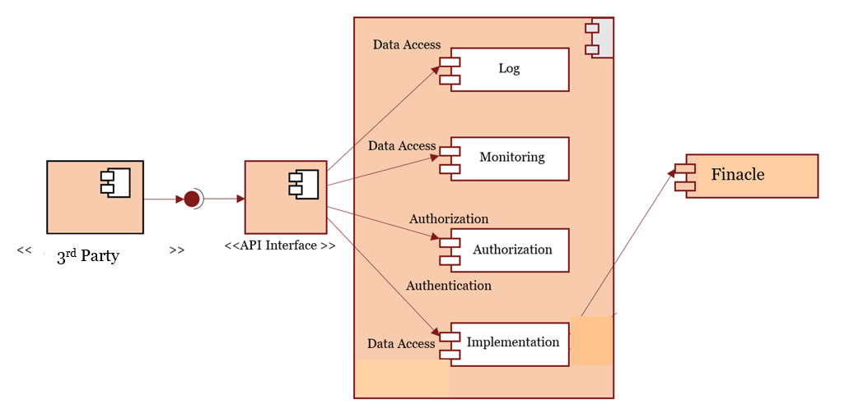

***COMPONENT DIAGRAM: FI MODULE***

***USE CASE DETAILS:***

|  |  |  |  |
| --- | --- | --- | --- |
| Use Case Id | Use Case Name | Description | API ID |
| UC-18 | Servicing of Savings Account Customers | IDBI wants digital servicing of its savings account customers for greater reach of its savings account product, thereby increasing cross sell opportunities by means of cross selling Loans, FD, RD, etc. | API 365 |
| UC-25 | GBG Customer Servicing | IDBI wants to use APIs to enable third party service providers in customer servicing for GBG department products |

### 

### Use Cases 18 & 25: Servicing of Savings Account Customers & GBG Customer Servicing

This API allows an external channel or a client to request for account details of a Customer account in IDBI Bank

**Endpoint**: {domainName}/api/{version}/finacle/accountinquiry

**Method**: POST

|  |  |
| --- | --- |
| USE Cases | Servicing of Savings Account Customers |
| GBG Customer Servicing |
| **ID** | 18 |
| 25 |
| **Actors** | 3rd Party / Bank / Customer |
| **Pre-Condition** | When a 3rd party application or customer wants to request for account details of a customer account id |
| **Flow of Events** | * Customer enters the accountid at bank/partner application * The API gateway validates the request and sends the request to IDBI internal systems for fetching details of account * IDBI internal systems respond with the account details/error, if any, which are displayed to the customer at bank/partner application |
| **Post-Condition** | When the 3rd Party application or customer will get the account details of a customer account id |

***TABLE 1: USE CASE 18 & 25 DETAILS***

**3rd Party**

**API Module**

**ESB**

**Finacle**

dispatch

Result

API Call

Return

Return

Return

ESB service call

Finacle service call

Return

***UML DIAGRAM: API 365***

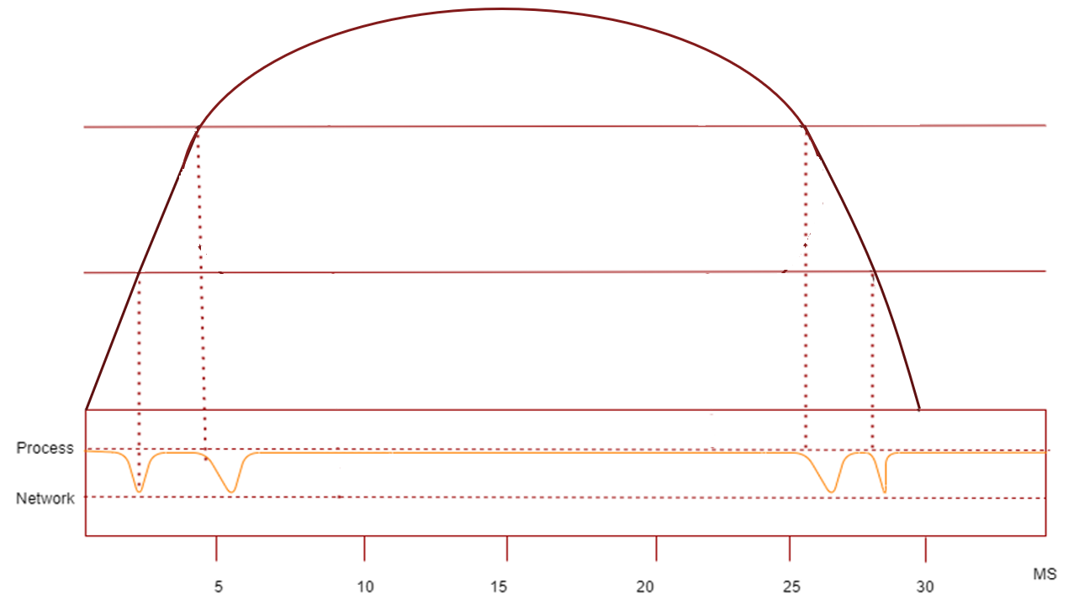

***TIME DIAGRAM: API 365***

**Finacle**

**ESB**

**API Gateway**

**API DETAILS:**

|  |  |  |
| --- | --- | --- |
| **Use Case ID** | 18 | |
| 25 | |
| **API ID** | 365 | |
| **API Name** | Perform Account Inquiry | |
| **API Description** | This API will take the account Id in request and return the details associated with the concerned account Id | |
| **API Type** | POST | |
| **Request** | {  “data”: {  "acctId": "String",  }  } | |
| **Response** | {  "response": {  "acctId": "string",  "acctType": {  "schmCode": "string",  "schmType": "string"  },  "acctCurr": "string",  "bankInfo": {  "bankId": "string",  "name": "string",  "branchId": "string",  "branchName": "string",  "postAddr": {  "addr1": "string",  "addr2": "string",  "addr3": "string",  "city": "string",  "stateProv": "string",  "postalCode": "string",  "country": "string",  "addrType": "string"  }  },  "custId": "string",  "personName": {  "lastName": "string",  "firstName": "string",  "middleName": "string",  "name": "string",  "titlePrefix": "string"  },  "acctOpenDt": "date",  "bankAcctStatusCode": "string",  "acctBal": {  "balType": "string",  "balAmt": {  "amountValue": "double",  "currencyCode": "string"  }  }  }  } | |
| **Authentication** | OAuth 2.o | |
| **Encryption** | TLS 2.0 | |
| **Logging** | API gateway level logging in the Elasticsearch | |
| **Monitoring** | API gateway level monitoring | |
| **Source System** | Bank application / 3rd party application | |
| **Endpoints** | {domainName}/api/{version}/finacle/accountinquiry | |
| **Triggering Event** | When 3rd Party or a customer wants to know the account details of a customer account id in IDBI Bank | |
| **Validation** | **Field name** | acctId |
| **Rule** | Max length is 16 |
| **Priority (Low/Medium/ High)** | High | |
| **Notes** |  | |

***TABLE 2: API DETAILS***